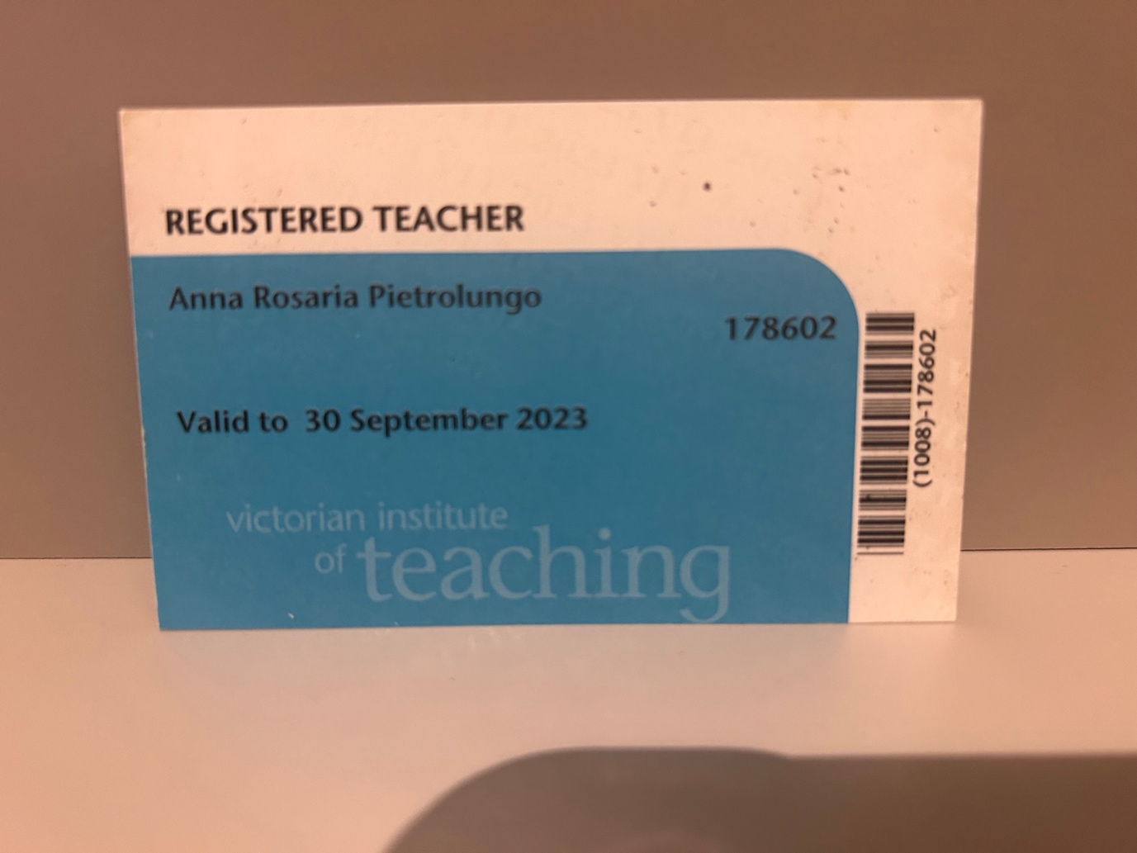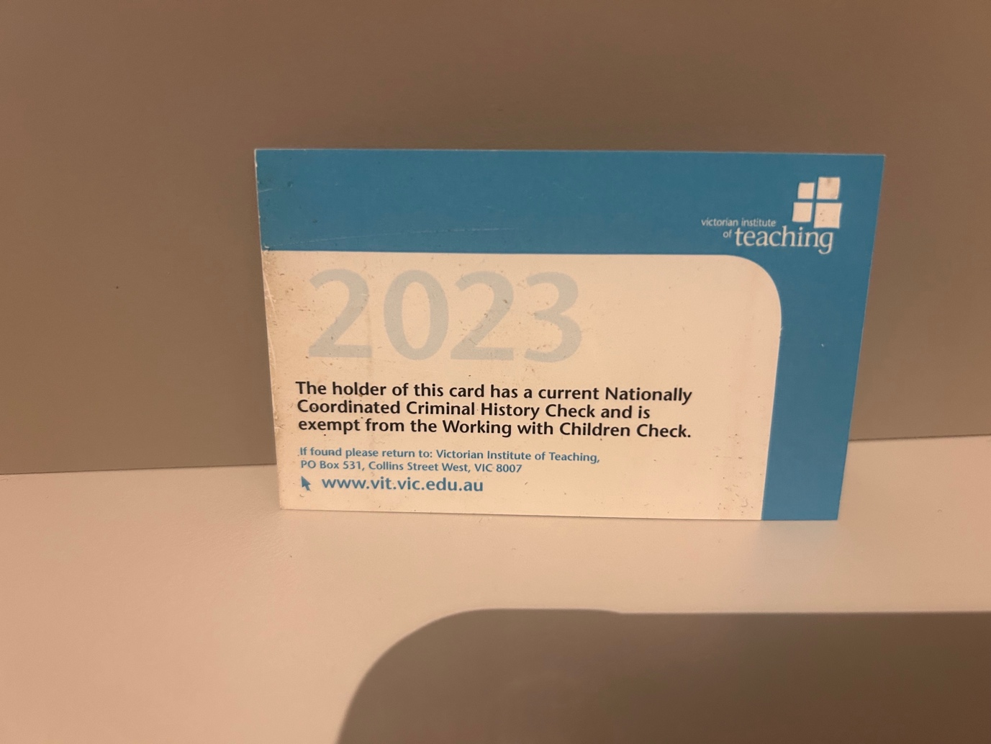

Hey Sarah,

The VIT registration covers working with children. I will send you new VIT details once I renew it.

Thanks
Anna

